You’re Invited to a Barbeque!
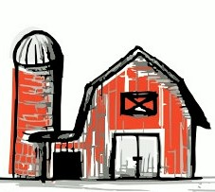
The Hartford County Farm Bureau welcomes you to the Annual Policy Development Meeting Barbeque.

Thursday, July 14, 2022 @ 6 pm Belltown Hill Orchards
483 Matson Hill Rd.
South Glastonbury, CT 06073

This is the perfect opportunity to get out and meet with fellow farmers. Come share concerns you or your fellow farmers are experiencing and provide input to the future of agriculture. Your input is valuable in developing policies for the Farm Bureau.
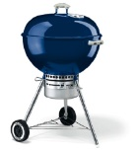
At the meeting, we will ask: What policy change, addition, deletion, or reaffirmation to the CFBA Policy Book is needed? Examples of issues are town livestock regulations, taxation, and zoning regulations.

Please RSVP to (860) 251-9318 or hcfb@comcast.net by July 6, 2021

* Beverages, hot dogs, hamburgers, sides, and dessert will be available *

